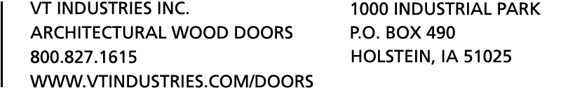  JOB NUMBER: |  |  |  |  |  |  |  | PAGE: |  |  |  | /
JOB NAME::
PLEASE CHECK ONE and CHECK OPTION |  |  |  |  | VISUAL LITE SIZE |  |  |  |  | CUTOUT SIZE
110 Vision Panel: |  | Primed |  | or | Painted (upcharge) |  |  |  | or | Veneer Wrapped (upcharge)
115 Vision Panel: |  | Primed |  | or | Painted (upcharge) |  |  |  | or | Veneer Wrapped (upcharge)
VT1 Woodstop: |  | Unfinished |  | or | Factory Finished
VT7 Woodstop:  NOTE: REFER TO LOCK/LITE LOCATION CHART FOR LITE CUTOUT LOCATION REQUIREMENTS. |  | Unfinished |  | or | Factory Finished
Other (please specify) :


EQ
EQ
EQ
EQ
EQ
EQ
List louver cutout size only
____ SHELF STOP FACE
____ SHELF HINGE FACE
____ SHELF CENTERED
BOTH FACES
DUTCH DOOR DETAIL
ADVISE SHELF SIZE
3"
VARIES
3"


FLUSH DOOR ELEVATIONS
Rev 5/04

