Project:  Rev 5/04 |  |  |  |  |  |  |  |  |  |  |  |  |  | VT#: |  |  |  |  |  |  |  |  |  | SLIDING DOORS
    Customer: |  |  |  |  |  |  |  |  |  |  |  |  |  | Door Type:
Door #: |  |  |  |  |  |  |  |  |  |  |  |  |  | Face Material:
Check Top Track Location Option |  |  |  |  |  |  |  |  |  |  |  |  |  |  |  |  |  |  |  |  |  |  |  | Check Door Position Option
Option 1: Track Mounted in Frame |  |  |  |  |  |  |  |  |  |  |  |  |  |  | Option 2: Flush Mounted Track |  |  |  |  |  |  |  |  | Option 1
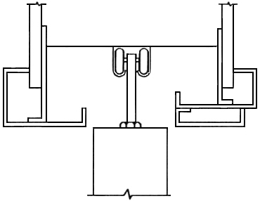 |  |  |  |  |  |  |  |  |  |  |  |  |  |  | 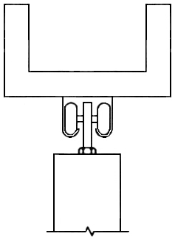
 |  |  |  |  |  |  |  |  |  |  |  |  |  |  |  |  |  |  |  |  |  |  |  | 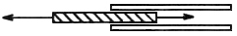
 |  |  |  |  |  |  |  |  |  |  |  |  |  |  |  |  |  |  |  |  |  |  |  | Option 2
 |  |  |  |  |  |  |  |  |  |  |  |  |  |  |  |  |  |  |  |  |  |  |  | 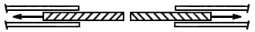
 |  |  |  |  |  |  |  |  |  |  |  |  |  |  |  |  |  |  |  |  |  |  |  | Option 3
 |  |  |  |  |  |  |  |  |  |  |  |  |  |  |  |  |  |  |  |  |  |  |  | 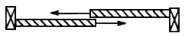
 |  |  |  |  |  |  |  |  |  |  |  |  | Top of Frame Opening |  |  |  |  |  |  |  | Top of Frame Opening
Frame Opening Width |  |  |  |  |  |  |  |  |  |  | Frame Opening Width
 |  |  |  |  |  |  |  |  |  |  |  |  |  |  |  |  |  |  |  |  |  | # of Leaves:
 |  |  |  |  |  |  |  |  |  |  |  |  |  |  |  |  |  |  |  |  |  | Thickness:
 |  |  |  |  |  |  |  |  |  |  |  |  |  |  |  |  |  |  |  |  |  | Net Size Each Leaf:
 |  |  |  |  |  |  |  |  | Frame |  |  |  |  |  |  |  |  |  |  | Frame
 |  |  |  |  |  |  |  |  | Opening |  |  |  |  |  |  |  |  |  |  | Opening |  | Mfg/Track Model#:
 |  |  |  |  |  |  |  |  | Height |  |  |  |  |  |  |  |  |  |  | Height
 |  |  |  |  |  |  |  |  |  |  |  |  |  |  |  |  |  |  |  |  |  | Mfg/Pull Model#:
 |  |  |  |  |  |  |  |  |  |  |  |  |  |  |  |  |  |  |  |  |  | Other Accessories:
 |  |  |  |  |  |  |  |  |  |  |  |  |  |  |  |  |  |  |  |  |  | Remarks:

